## **Workflow :- HMIS to HRMS Integration**

1. **Login to HMIS (artemlc).**
2. **Create a New Employee:**

* **Navigate to: HR >> Employee Map**
* **Add the employee details.**

1. **Create User Login:**

* **Go to: User >> User Login**
* **Set up login credentials for the newly created employee.**

1. **Assign Roles/Rights:**

* **Grant access to:**
  + **hr-frappe**
  + **roster**

1. **Test the User Login:**

* **Log in using the new user's credentials.**

1. **Access Employee Dashboard:**

* **Click on the hr-portal app.**
* **It will redirect to the employee's dashboard.**

## **HRMS Functions**

1. **Employee Records and Documentation**
   1. Login to HRMS
      1. Employee Dashboard
      2. Overview → Employee

* Create, view, and update employee profiles, including personal details such as name, contact info, address, and emergency contacts
* **Roles Involved**
  + **Administrator (BMC Admin) :** Manage access rights and system-level document settings.
  + **HR Manager (Care Provider wise HR) :** Full access to view/edit all employee documents of their organization.
  + **Employee (Doctors, Nurses, etc.)** : Restricted access to view personal profile.
  + **Leave Approver :** Reporting manager or HR who will approve leaves.
  + **Shift Approver :** Reporting manager or HR who will approve/assign shifts.
  + **Expense Approver :** Reporting manager or HR who will approve additional expenses.

[](https://drive.google.com/file/d/1iq_6Bfoh2TH1I1hZhglsKHtM0WPoPfxY/view?usp=drive_link)

**EXAMPLE EMPLOYEE HIERARCHY:-**



1. **Workforce Planning and Recruitment**
   1. Staffing needs & planning : Create job openings, track applicants, and manage interviews and feedback.
      1. Recruitment → Jobs → Staffing Plans
   2. Recruitment strategies : Create and publish job openings, and review applicant profiles.
      1. Recruitment → Jobs → Job Opening
      2. Recruitment → Jobs → Job Applicant
   3. Interview process : Schedule interviews, collect interviewer feedback, and record results for candidates.
      1. {Pre requisite} Recruitment → Interview Type → Interview Round Setup
      2. Recruitment → Jobs → Interview
      3. Recruitment → Jobs → Interview Feedback
      4. Recruitment → Jobs → Interview Round
   4. Reference & background checks : Maintain and review candidate references and background verification details.
      1. Recruitment → Jobs → Employee Reference
   5. Onboarding : Assign onboarding templates, track status, and enable new hires to complete required tasks.
      1. Employee Lifecycle → Onboarding → Employee Onboarding Template
      2. Employee Lifecycle → Onboarding → Employee Onboarding

* Separate Dashboard to view open positions, track hiring status, and monitor overall recruitment progress.
* Job Portal URL: https://{your-domain}/jobs
  + (Example: <https://hrms.uat.bmchealth.in:8000/jobs> )
* **Roles Involved**
  + **HR Manager :** Oversees planning, approvals, and onboarding.
  + **New Employee :** Views and completes onboarding tasks.

[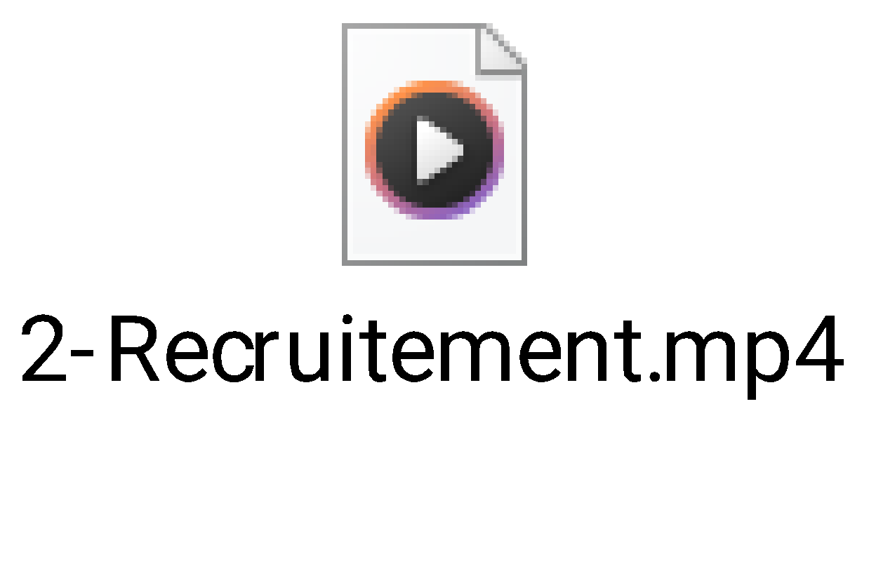](https://drive.google.com/file/d/1BOt9C5XLyfnoTQrIrm01a7pIC7Tx1jeF/view?usp=drive_link)

1. **Training & Development**
   1. Training needs, design : Plan and create training events and programs based on role and skill requirements.
      1. Employee Lifecycle → Training → Training Event
      2. Employee Lifecycle → Training → Training Program
      3. Employee Lifecycle → Training → Training Result
   2. Professional development : Enhance employee skills through training events and review outcomes.
   3. Performance management : Set and review employee performance goals and appraisal results.
      1. Performance → Appraisal
      2. Performance → Goal

* **Roles Involved**
  + **HR Manager :** Designs training programs, manages performance review cycles.
  + **Team Lead / Manager :** Recommends training, sets goals, and evaluates performance.
  + **Employee :** Views assigned training, sets goals, participates in appraisals.

[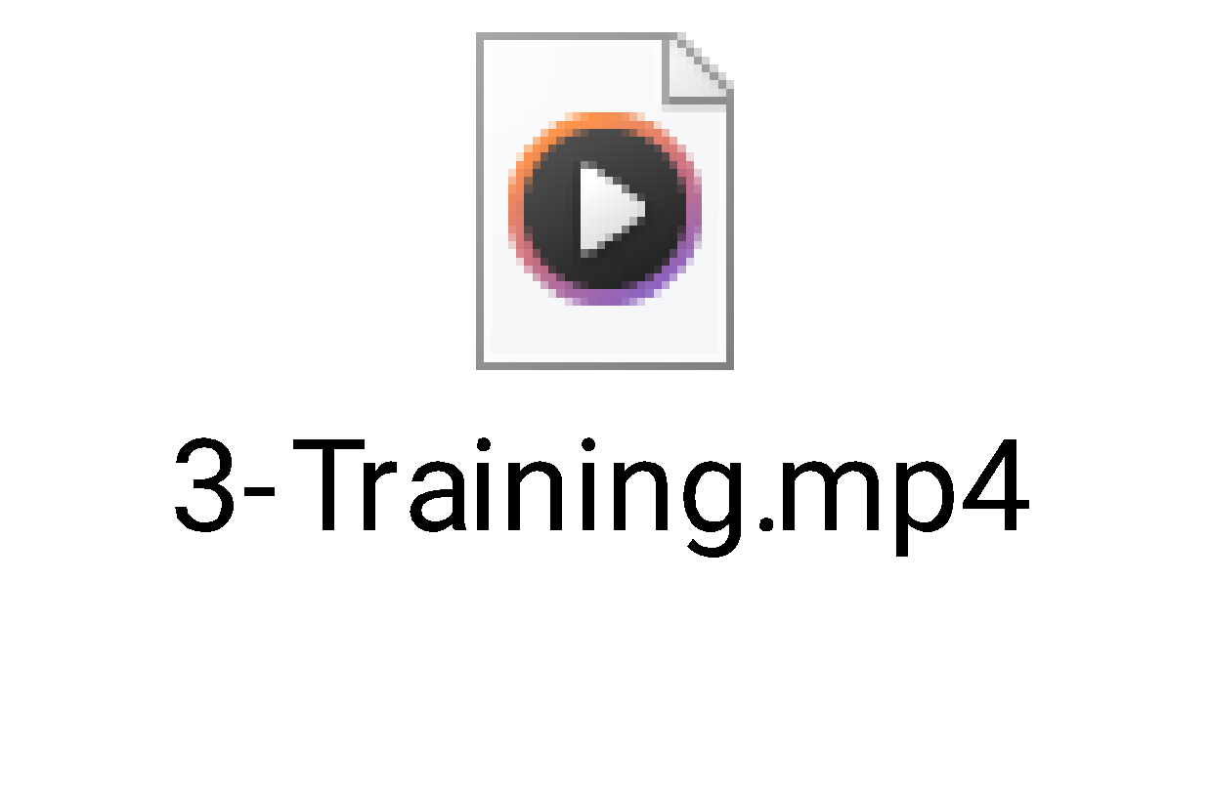](https://drive.google.com/file/d/18jsRxrLyCI7dTI_vKkLq-_u-S1Hy3XOz/view?usp=drive_link)

1. **Employee Benefits and Compensation** 
   1. Benefits program : Manage employee benefit applications and approvals.
   2. Payroll & salary : Create payroll entries and process salary slips.
      1. Salary Payout → Payroll Entry
      2. Salary Payout → Salary Slip
   3. Compensation structures : Maintain salary components, salary structures, incentives, and bonuses.
      1. Salary Payout → Incentives → Additional Salary
      2. Salary Payout → Incentives → Retention Bonus

* **Pre-requisits**
  + Salary Component (Salary Payout → Masters → Salary Component)
  + Salary Structure (Salary Payout → Masters → Salary Structure)
  + Salary Structure Assignment (Salary Payout → Payroll → Bulk Salary Structure Assignment)
  + Payroll Period (Salary Payout → Masters → Payroll Period)
  + Salary Slip Format (ERPNext → Home → Letter Head)
* **Role Involved**
  + **HR Manager :** Configure salary structures, run payroll, manage benefits.
  + **Employee :** View salary slips, apply for benefits.

[](https://drive.google.com/file/d/1nEe7yJef_I1K2mcuJI7MDahsEJKAfpbo/view?usp=drive_link)

1. **HR Information Systems and Technology**
   1. HRIS : Maintain employee records within the core ERPNext HR module.
   2. Self-Service Portals (Employee Portal) : Enables employees to view/edit profiles, access pay slips, and apply for leave.
   3. Time and attendance : Maintain shift schedules, manage employee check‑ins, and review attendance.
      1. Shift & Attendance → Attendance
      2. Shift & Attendance → Employee Check-in
      3. Shift & Attendance → Shift Assignment → List View → Calendar View
   4. Leaves : Apply and manage leave requests, policies, and allocations.
      1. Leaves → Leave Application

* **Pre-requisits**
  + **FOR SHIFT/ROSTER :**
  + Shift Type (Shift & Attendance → Shift → Shift Type)
  + Shift Location (Shift & Attendance → Shift → Shift Location)
  + Shift Schedule (Shift & Attendance → Shift → Shift Schedule)
  + Shift Assignment (Shift & Attendance → Shift → Shift Assignment)
  + **FOR LEAVE :**
  + Leave Type (Leaves → Setup → Leave Type)
  + Leave Period (Leaves → Setup → Leave Period)
  + Leave Policy (Leaves → Setup → Leave Policy)
  + Leave Policy Assignment (Leaves → Allocation → Leave Policy Assignment)
* **Role Involved**
  + **HR Manager :** Full control over all HRIS settings; can configure shifts, approve leaves, manage attendance.
  + **Employee :** Self-service access to view profile, apply for leave, view pay slips, and check attendance.
  + **Leave Approver :** Typically a reporting manager; receives and acts on leave requests from direct reports.

[](https://drive.google.com/file/d/1qKWw92r9H2QFhaXkq8Cknj-0XO5obFu5/view?usp=drive_link)